For loop
Workshop #3
Flutter Developer Bootcamp

Purpose
This workshop demonstrates the use of a for loop to iterate over a range of integers (start to end) and perform a set of operations (in this case, printing each integer).

Problem
In the given workshop demonstrates StringInputStream and assigns it to a variable stream, although correct instantiation should use StringInputStream() to create an object. The main() function initializes variables start and end, then uses a for loop to print numbers from 0 to 3 sequentially. This example introduces basic Dart syntax, including variable declaration, class definition, and loop usage, providing foundational understanding for further programming concepts in Dart. You need to print numbers from 0 to 5 sequentially.

How to Solve
- Checkout the workshop from Git Repo:
git clone -b <user-branch> <repo-URL>
- Open the root folder inside VS Code
- Open the root folder in terminal
- Run the command dart run filename.dart
- Instantiate StringInputStream correctly using StringInputStream() to create an object.
- Declare stream variable and assign it an instance of StringInputStream().
- Initialize start variable to 0 and end variable to 5.
- Utilize a for loop to iterate from start to end, inclusive (0 to 5).
- Print each value of i during each iteration of the loop using print(i).
- Go To File: <specific-file--method> à <method-name>, implement your logic.

You will Achieve
When you complete this workshop you will learn the following:

Methods and Functions Used:

- main() Function:
- Entry point of the Dart program where execution begins.
- Initializes variables and controls the flow of the program.
- Class Instantiation (StringInputStream()):
- Correctly instantiates the StringInputStream class to create an object instance.
- Variable Declaration and Initialization:
- Demonstrates the use of var keyword for variable declaration (var stream, var start, var end).
- For Loop:
- Uses a for loop to implement iterative behavior, iterating over a sequence of integers (int i = start; i <= end; i++).
- Print Function (print(i))
- Outputs the current value of i to the console during each iteration of the loop.

Screenshots

Before implementation (without printing 5 numbers)

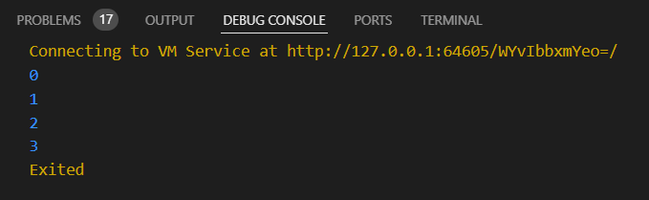

After implementation (with printing 5 numbers)

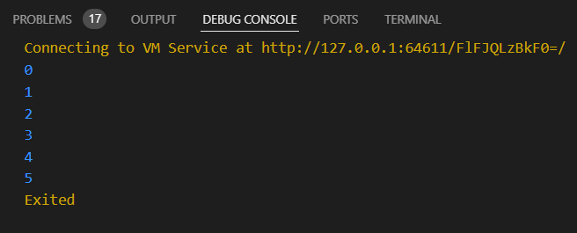

How to submit your workshop
Push your project back to the same git branch using command:
<command name>

Happy Coding!

